Q3 2026 Business Review
Prepared by the Finance team · October 14, 2026

Summary
Revenue reached $586k, up 18% on Q2. Growth came mostly from new business customers in Europe, while costs stayed within budget.

Highlights
- Signed 42 new business customers
- Opened the Berlin office in August
- Launched the mobile app in 22 languages
- Customer satisfaction rose to 4.7 / 5

Revenue by region
Region | Revenue | Growth
North America | $248k | +12%
Europe | $221k | +31%
Asia Pacific | $117k | +9%

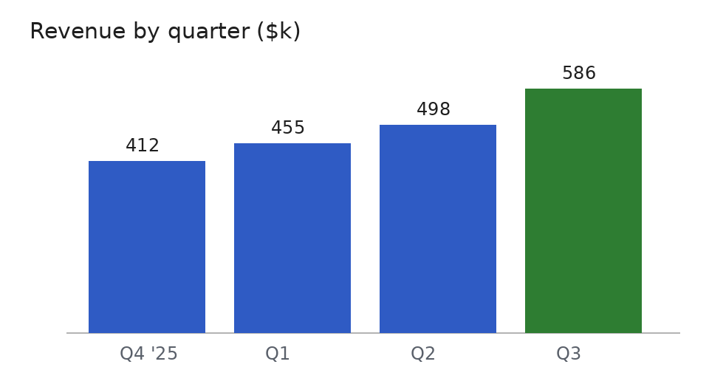

Next steps
- Hire two account managers for Europe
- Ship the Tools tab to all customers
- Review pricing before the Q4 campaign
Full figures are in the attached budget workbook.

